Packet Tracer – Comparing RIP and EIGRP Path Selection

Topology

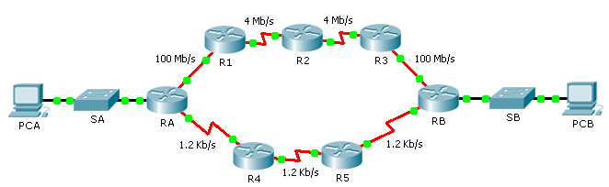

1. Objectives

Part 1: Predict the Path

Part 2: Trace the Route

Part 3: Reflection Questions

1. Scenario

**PCA** and **PCB** need to communicate. The path that the data takes between these end devices can travel through **R1**, **R2**, and **R3,** or it can travel through **R4** and **R5**. The process by which routers select the best path depends on the routing protocol. We will examine the behavior of two distance vector routing protocols, Enhanced Interior Gateway Routing Protocol (EIGRP) and Routing Information Protocol version 2 (RIPv2).

1. Predict the Path

Metrics are factors that can be measured. Routing protocols are each designed to consider various metrics when considering which route is the best to send data along. These metrics include, hop count, bandwidth, delay, reliability, path cost, and more.

* 1. Consider EIGRP Metrics.
     1. EIGRP can consider many metrics. By default, however, bandwidth and delay are used to determine best path selection.
     2. Based on the metrics, what path would you predict data would take from **PCA** to **PCB**?

____________________________________________________________________________________

* 1. Consider RIP Metrics.
     1. What metric(s) are used by RIP? __________________
     2. Based on the metrics, what path would you predict data would take from **PCA** to **PCB**?

____________________________________________________________________________________

1. Trace the Route
   1. Examine the EIGRP Path.
      1. On **RA**, view the routing table using the appropriate command. Which protocol codes are listed in the table and what protocols do they represent? ________________________________________________
      2. Trace the route from **PCA** to **PCB**.

What path does the data take? ___________________________________________________________

How many hops away is the destination? __________________

What is the minimum bandwidth on the path? __________________

* 1. Examine the RIPv2 Path.

You may have noticed that, while RIPv2 is configured, the routers ignore the routes that it generates, because they prefer EIGRP. Cisco routers use a scale called administrative distance and we need to change that number for RIPv2 in **RA** to make the router prefer the protocol.

* + 1. For reference purposes, show the routing table of **RA** using the appropriate command. What is the first number between the brackets in each EIGRP route entry? __________________
    2. Set the administrative distance for RIPv2 using the following commands. This forces **RA** to choose RIP routes over EIGRP routes.

RA(config)# **router rip**

RA(config-router)# **distance 89**

* + 1. Wait a minute and show the routing table again. Which protocol codes are listed in the table and what protocols do they represent? ____________________________________
    2. Trace the route from **PCA** to **PCB**.

What path does the data take? ___________________________________________________________

How many hops away is the destination? __________________

What is the minimum bandwidth on the path? __________________

* + 1. What is the first number between the brackets in each RIP entry? __________________

1. Reflection Questions
   1. What metrics does the RIPv2 routing protocol ignore? ____________________________________________

How could this affect its performance? ________________________________________________________

* 1. What metrics does the EIGRP routing protocol ignore? __________________

How could this affect its performance?

_______________________________________________________________________________________

* 1. Which do you prefer for your own Internet access, lower hops or more bandwidth? _____________________
  2. Is one routing protocol suitable for all applications? Why?

_______________________________________________________________________________________

_______________________________________________________________________________________

_______________________________________________________________________________________

Suggested Scoring Rubric

|  |  |  |  |
| --- | --- | --- | --- |
| Activity Section | Question Location | Possible Points | Earned Points |
| Part 1: Predict the Path | Step 1-b | 8 |  |
| Step 2-a | 8 |  |
| Step 2-b | 8 |  |
| **Part 1 Total** | | **24** |  |
| Part 2: Trace the Route | Step 1-a | 8 |  |
| Step 1-b | 8 |  |
| Step 2-a | 8 |  |
| Step 2-c | 8 |  |
| Step 2-d | 8 |  |
| Step 2-e | 8 |  |
| **Part 2 Total** | | **48** |  |
| Part 3: Reflection Questions | 1 | 7 |  |
| 2 | 7 |  |
| 3 | 7 |  |
| 4 | 7 |  |
| **Part 3 Total** | | **28** |  |
| **Total Score** | | **100** |  |